CARIBU Background Analysis

Purpose:

The “X-Array and SATURN” is a sensitive experimental setup for beta-decay spectroscopy of neutron-rich nuclei produced at the CARIBU facility. To understand the lower limits of sensitivity when looking for either very exotic isotopes, or very weak transitions in strongly produced isotopes, the rate of “background” triggers is very important. Without a radioactive beam present, the probability of beta-gamma-gamma coincidences is expected to be vanishingly low. In a normal environment this would be true, triggers would probably occur at a rate of a few per second. However, “background” in the CARIBU experimental hall is much more hostile, and raises the ambient trigger rate in High-Purity Germanium (HPGe) detectors by two orders of magnitude. This has been problematic both for beam tuning and optimization, as well as for real experiments.

The background in the current low-energy CARIBU hall has proven to come mainly from the CARIBU gas-catcher, due to the presence of the 1 mCi 252Cf source. The main interfering background is induced by fission neutrons, particularly the 56Fe(n,g) reaction. Gamma-rays with energies greater than 7 MeV have been seen in spectra (Figure 1) collected with the high-efficiency HPGe clover-detectors of X-Array (which is roughly 4 meters away from the 252Cf gas-catcher).



*Figure 1: Background spectrum collected in the CARIBU hall for ~8 hours with X-Array (20 detectors total—four per clover) located in it’s experimental position.*

The spectrum has two dominant features: the “Ski Ramp” of scattered radiation below 511 keV, and the strong gamma-rays from 56Fe(n,g) at 7.6 MeV. The spectrum does not fall to zero counts until after 9.7 MeV.

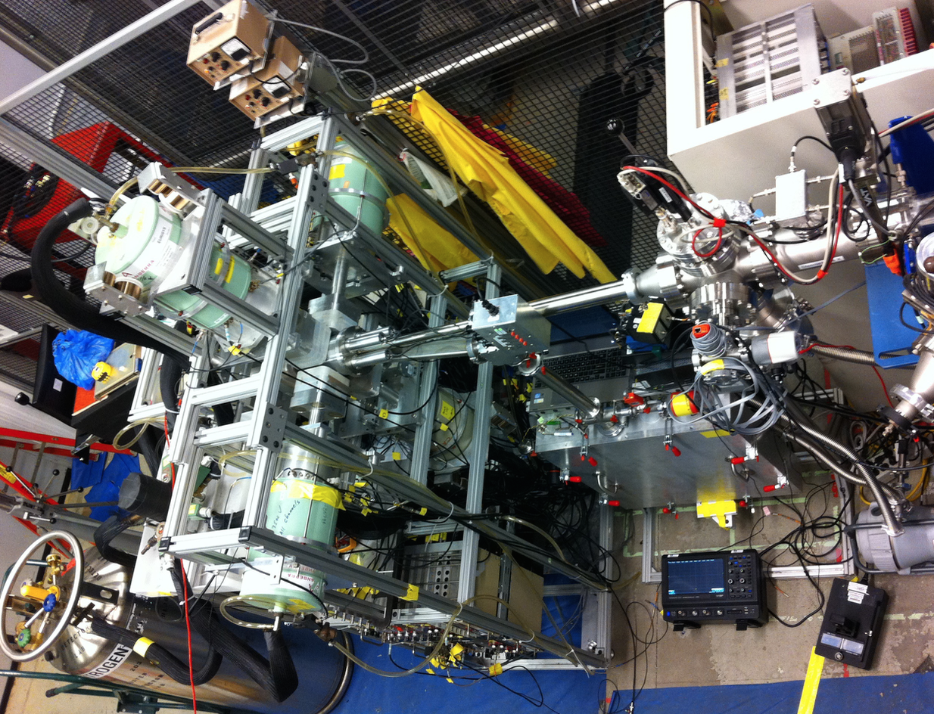

Another detector system recently commissioned at the low-energy CARIBU beam line was the Total Absorption Gamma-ray Spectrometer (TAGS) on long-term loan from Idaho National Engineering Laboratory (Figure 3). The TAGS technique is used for calorimetric measurements of neutron-rich fission products for reactor “decay heat” calculations. This large-volume NaI detector has an efficiency of ~95% and had to be shielded by over 2,000 lbs of lead and borated-polyethylene to prevent environmental background radiation from contaminating spectra of neutron-rich isotopes.

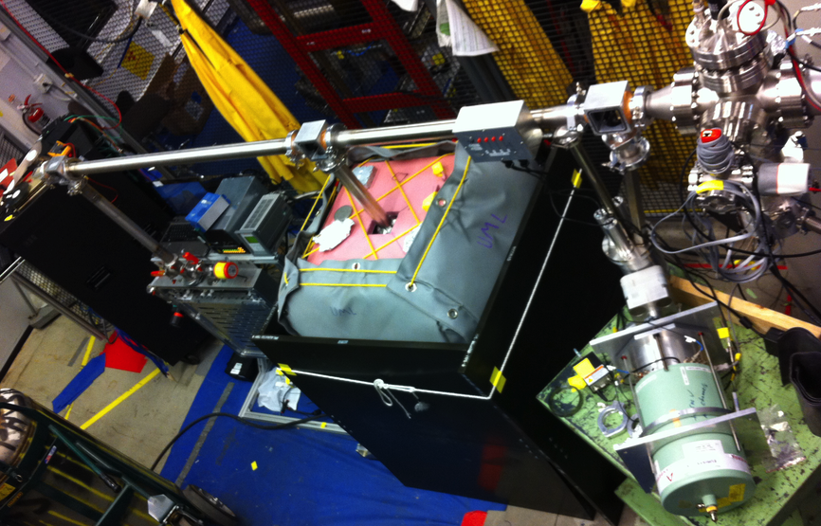

*Figure 3: Picture of the shielded TAGS detector (center) installed with SATURN (left center) on the low-energy beam line in the CARIBU hall.*

However, over 2,000 lbs of lead proved to be insufficient for the high efficiency of the TAGS calorimeter. Inside the shielding, each of the seven photomultiplier tubes that view the sensitive volume of the NaI crystal were triggering at an average rate of 1,200 Hz (compared to 300 Hz in a testing room outside the CARIBU hall). This means that measurements cannot acquire sufficient statistics unless the beam intensity is on the order of 1,000 ions/sec, which is difficult to achieve for the most exotic short-lived nuclei.



*Figure 4: TAGS spectrum collected for 8 hours in the low-energy CARIBU hall while inside the shielding structure.*

To overcome this background radiation, the most viable solution is to perform measurements outside of the current CARIBU hall. Plans have been made to remove the tandem tank that has been decommissioned from the ATLAS accelerator system. A beam line is being designed to send ions from CARIBU through the Electron Beam Ion Source (EBIS) charge breeder and into the tandem hall where the new low-energy experimental area will be. The observations of background impelled an investigation as to the exact sources of all the high-energy gamma-rays shown in Figure 1 and Figure 4, and required detailed comparison with the environment in the tandem area.

CARIBU Background Measurement:

Preliminary analysis of the background spectrum collected with X-Array revealed neutron-capture reactions, on materials in the 252Cf shielding, as the primary source of high-energy radiation. The reaction 56Fe(n,g)57Fe was originally identified from the gamma-rays at 7631 and 7645 keV, including the fact there is a large amount of steel in the 252Cf cask. Steel is an iron-alloy that contains chromium (Cr) and small amounts of nickel (Ni), manganese (Mn), silicon (Si), sulfur (S), carbon (C), and phosphorus (P). Borated-polyethylene is also present within the shielding cask and around the gas-catcher to thermalize neutrons emitted during the fission process.

*Figure 5: The “super-clover” detector from X-Array (center, outlined in red) aligned with respect to the implant point of SATURN (left, at the arrow’s head) and the CARIBU gas-catcher (right, at the arrow’s base).*

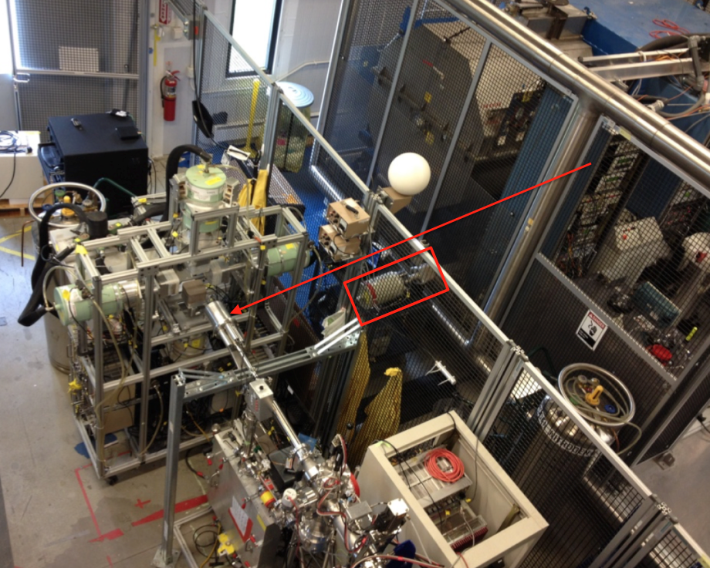

*Figure 6: Background spectrum collected for 8 hours approximately 2m from the CARIBU gas-catcher (with clover E4 only). Peaks corresponding to the primary sources of background have been labeled. All other peaks from 4-10 MeV are 1st and 2nd escape peaks of the primary sources.*



The “super-clover” (most efficient detector) was removed from X-Array and positioned approximately 2 meters away from the CARIBU gas-catcher (Figure 5) and aligned with the plastic scintillator of SATURN (where beam is implanted on the tape during experiments). A spectrum was collected (Figure 6) with crystal E4 for 8 hours. (Only one of the four crystals was used because only a single-channel analog MCA was available at the time of data collection).

The spectrum in Figure 6 has many high-energy gamma-rays that originate from reactions other than 56Fe(n,g) (Table 1). It is important to note that the spectrum does not fall to zero counts until above 9.7 MeV. At 8 MeV, the continuum has approximately 70 counts, which corresponds to a count rate of ~9 counts per hour.

*Table 1: Identified sources of gamma-rays and peak areas (above the continuum) from the spectrum collected between X-Array and the CARIBU gas-catcher.*

|  |  |  |
| --- | --- | --- |
| **Eg (keV)** | **Source** | **Peak Area** |
| 511 | e-/e+ annihilation | 458352 |
| 1460.6 | 40K (concrete) | 7091 |
| 2223.3 | 1H(n,g) (polyethylene) | 5469 |
| 2614.5 | 208Pb (radon gas) | 1279 |
| 4218.7 | 56Fe(n,g) | 638 |
| 4898.0 | 2nd Escape of 56Fe (5920) | 542 |
| 4997.0 | 1st Escape of 56Fe (5507) | 648 |
| 5409.3 | 1st Escape of 56Fe (5920) | 1546 |
| 5507.4 | 56Fe(n,g) | 1554 |
| 5920.9 | 56Fe(n,g) | 1994 |
| 6019.0 | 56Fe(n,g) | 1804 |
| 6254.2 | 2nd Escape of 56Fe (7279) | 523 |
| 6608.7 | 2nd Escape of 56Fe (7631) | 3082 |
| 6623.1 | 2nd Escape of 56Fe (7645) | 2517 |
| 6766.9 | 1st Escape of 56Fe (7279) | 1260 |
| 7118.5 | 1st Escape of 56Fe (7631) | 7354 |
| 7132.7 | 1st Escape of 56Fe (7645) | 5800 |
| 7279.5 | 56Fe(n,g) | 1220 |
| 7427.0 | 1st Escape of 52Cr (7938) | 715 |
| **Eg (keV)** | **Source** | **Peak Area** |
| 7631.9 | 56Fe(n,g) | 6853 |
| 7646.4 | 56Fe(n,g) | 4842 |
| 7860.3 | 2nd Escape of 53Cr (8884) | 679 |
| 7939.1 | 52Cr(n,g) | 531 |
| 7973.8 | 2nd Escape of 58Ni (8998) | 716 |
| 8000.7 | 1st Escape of 50Cr (8512) | 373 |
| 8021.9 | 1st Escape of 58Ni (8533) | 483 |
| 8274.6 | 2nd Escape of 56Fe (9297) | 393 |
| 8372.1 | 1st Escape of 53Cr (8884) | 1789 |
| 8486.6 | 1st Escape of 58Ni (8998) | 1512 |
| 8512.7 | 50Cr(n,g) | 374 |
| 8534.4 | 58Ni(n,g) | 398 |
| 8695.0 | 2nd Escape of 53Cr (9719) | 233 |
| 8785.5 | 1st Escape of 56Fe (9297) | 953 |
| 8884.0 | 53Cr(n,g) | 1333 |
| 8999.1 | 58Ni(n,g) | 827 |
| 9206.1 | 1st Escape of 53Cr (9719) | 540 |
| 9297.6 | 56Fe(n,g) | 751 |
| 9718.3 | 53Cr(n,g) | 393 |

Tandem Area Measurement 1:

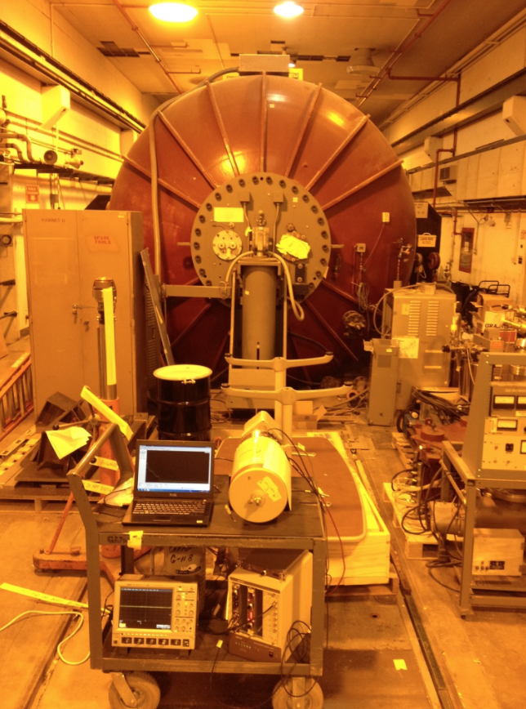 The first measurement in the tandem hall was taken roughly 3.5 meters away from the edge of the tank on the “ATLAS side”. Background was collected for 8 hours with no known radioactive sources near the detector.

The spectrum has many more peaks than anticipated, likely due to the long-lived decay of materials activated in the tank during its time of operation. However, the two most significant features are: (i) there are no peaks greater in energy than the 2614-keV gamma-ray from 208Pb, and (ii) the “ski ramp” of low-energy counts is two orders of magnitude lower than in the CARIBU hall.

*Figure 7 (right): Position of “super-clover” in the tandem area located on the “ATLAS side” and aligned with the center of the tandem tank (Tandem 1).*

*Figure 8: Background spectrum collected on the “ATLAS side” of the tandem tank for 8 hours (Tandem 1).*



Tandem Area Measurement 2:

The second measurement in the tandem area was made approximately 1.75 meters away from where the beam line will come from EBIS (in the direction away from ATLAS) and about 1.25 meters away (perpendicular) from the wall. Background was collected for 8 hours again with no known radioactive sources near the detector.

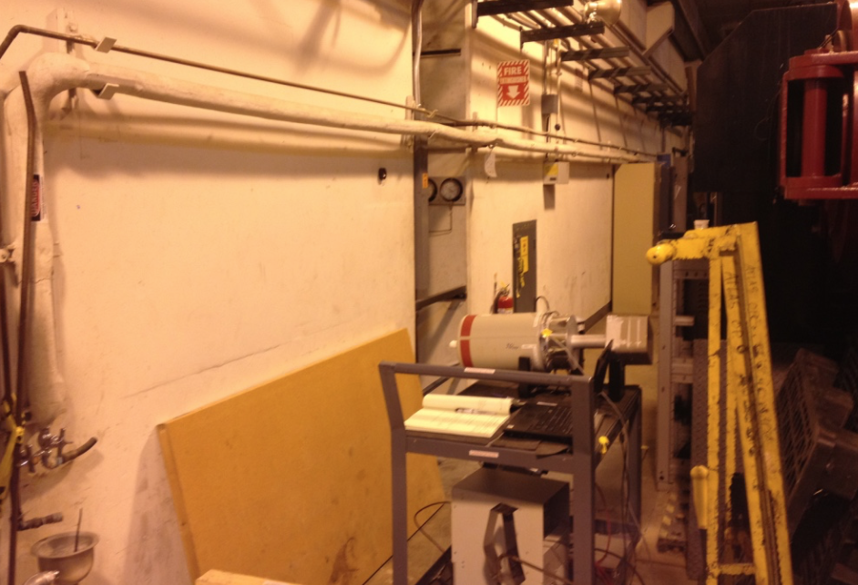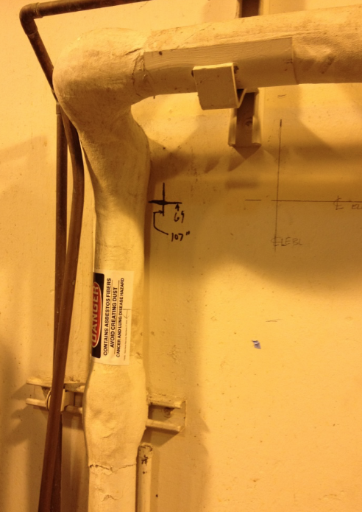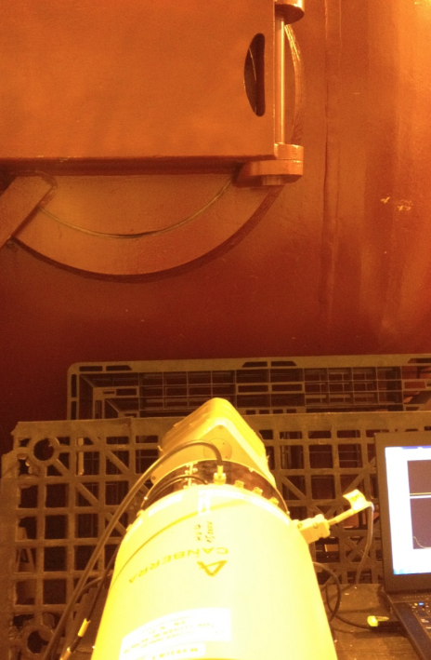

The same peaks are seen as in the Tandem 1 measurement, but with greater intensity. This shows that the tandem tank is the primary source of environmental background radiation in this area. However, it is not possible to determine the source of origin (radioactive nucleus) by gamma-ray energy alone. There are 1000s of nuclei that emit low-energy gamma-rays below 2614 keV. More information is needed, namely the half-life, before the exact source can be determined. This will require repeated measurements of the long-lived activity (one 8-hour collection period per month) in order to plot counts vs. time and extract half-life information from the data.

*Figure 9: Position of the “super-clover” (center) with respect to the proposed beam line from EBIS (left, dark black cross) and the tandem tank (right) (Tandem 2).*

*Figure 10: Gamma-singles spectrum collected approximately 0.75 meters from the tandem tank (Tandem 2), and close to where the beam line will come from EBIS.*



Results:

The “low-energy bump” was broken up into individual regions of 50-keV intervals. The count rate in each region was calculated by dividing the total sum by the collection time. Count rates for the 511-keV and 1460-keV peak were calculated from the background-subtracted area. The count rate of the continuum was estimated from the average number of counts (10 keV before each peak) divided by the collection time.

*Table 4: Comparison of count rates at different energies in the CARIBU hall and at two locations in the Tandem Area. Count rates are rounded to the nearest integer value and given in the lowest reasonable unit of time to compare locations: counts/min (cpm) or counts/sec (cps).*

|  |  |  |  |
| --- | --- | --- | --- |
| **Energy Range (keV)** | **CARIBU Integral (Rate)** | **Tandem 1 Integral (Rate)** | **Tandem 2 Integral (Rate)** |
| **1 to 50** | 1,381,919 (2,879 cpm) | 14,440 (30 cpm) | 27,279 (57 cpm) |
| **51 to 100** | 8,740,401 (303 cps) | 122,839 (4 cps) | 195,177 (7 cps) |
| **101 to 150** | 10,101,779 (351 cps) | 135,803 (5 cps) | 232,708 (8 cps) |
| **151 to 200** | 7,567,665 (263 cps) | 93,656 (3 cps) | 190,811 (7 cps) |
| **201 to 250** | 5,304,801 (184 cps) | 70,172 (2 cps) | 143,759 (5 cps) |
| **251 to 300** | 3,711,909 (129 cps) | 46,322 (2 cps) | 103,733 (4 cps) |
| **301 to 350** | 2,666,930 (93 cps) | 31,426 (1 cps) | 86,592 (3 cps) |
| **351 to 400** | 1,910,852 (66 cps) | 27,635 (1 cps) | 61,557 (2 cps) |
| **401 to 450** | 1,415,401 (2,949 cpm) | 18,448 (38 cpm) | 46,994 (98 cpm) |
| **451 to 500** | 1,110,325 (2,313 cpm) | 15,436 (32 cpm) | 36,586 (76 cpm) |

The rate is 5 times lower in the low-energy bump from 0-100 keV. In the 101-200 keV region the rate is nearly 6 times lower in the tandem hall than next to the CARIBU cask. From 201 to 300 keV the rate in the tandem area is 4 times lower, and from 301 to 400 keV the rate is 3.3 times lower in the tandem area than next to the cask.

There are no peaks above 2614 keV in either of the tandem spectra, and the average number of counts in the continuum was 2 over an 8-hour collection time. The count rate at 8 MeV is nearly two orders of magnitude lower in the tandem area (at both locations) than next to the CARIBU cask.

*Table 5: Comparison of counts and rates in the CARIBU hall with the two positions in the tandem hall. The low-energy bump (“ski ramp”) integral is the sum of all counts from 1 to 500 keV, while the areas of the 511-keV and 1460-keV peaks are the sum of the counts above the continuum. Note: The rate of the 1461-keV peaks should be the same, but the high level of the continuum in CARIBU reduces the number of valid counts in a peak.*

|  |  |  |  |
| --- | --- | --- | --- |
| **Energy Regime** | **CARIBU Counts (Rate)** | **Tandem 1 Counts (Rate)** | **Tandem 2 Counts (Rate)** |
| **“Ski Ramp” Integral** | 43,268,528 (1,502 cps) | 564,546 (20 cps) | 1,101,435 (38 cps) |
| **511 keV Area** | 458,352 (955 cpm) | 4885 (10 cpm) | 158,587 (330 cpm) |
| **1461 keV Area** | 7091 (15 cpm) | 28,049 (58 cpm) | 21,143 (44 cpm) |
| **2614 keV Area** | 1279 (3 cpm) | 4605 (9 cpm) | 3588 (8 cpm) |

Conclusion:

In conclusion, gamma-ray spectra of environmental background radiation were collected in the low-energy CARIBU hall and in the Tandem hall. The primary source of background in the CARIBU hall comes from neutron-capture reactions induced by fission-neutrons on materials used to shield the 252Cf source (mainly steel and borated-polyethylene). In the Tandem area, background is two orders of magnitude lower (or more) than in the CARIBU hall, and the primary source comes from materials inside the tandem tank that were activated during its long period of operation. An over-lay plot of each spectrum collected is shown in Figure 11 for comparison. Once the tandem tank is removed from the area (scheduled for December, 2016) background is expected to decrease by nearly one more order of magnitude. This makes the tandem hall the ideal location for the new CARIBU low-energy beam line, as sensitivity to high-energy and/or high-intensity gamma-rays increases significantly.



*Figure 11: Over-lay plot of each background spectrum measured in the CARIBU hall (green), Tandem 1 (blue) and Tandem 2 (red). The tandem spectra were multiplied by a normalization factor to match the area (above the continuum) of the 1461-keV peak to that of the CARIBU 1461-keV peak. This was done as 1461 keV comes from concrete, which is highly abundant at all three locations, and thus should be equally present in each spectrum.*